**Operating Systems Lab-3**

**Shell Programming (Part II)**



Submitted By: **Awais Saddiqui**

Registration# **21pwcse1993**

Section: **“A”**

Submitted to:

**Mam Madiha Sher**

**Department of Computer Systems Engineering**

**University of Engineering and Technology, Peshawar.**

**Objectives:**

The aim of this laboratory is to learn and practice SHELL scripts by writing small SHELL programs.

The following are the primary objectives of this lab session:

* SHELL keywords
* Arithmetic in SHELL script
* Control Structures
* Decision control
* Repetition control
* More UNIX commands
* Executing commands during login time

# Handling shell variables:

The shell has several variables which are automatically set whenever you login.

The values of some of these variables are stored in [names](https://www.nectec.or.th/net-guide/Unixhelp/scrpt_scrpt2.2.1.html#scrpt2.2.1) which collectively are called you user environment.

Any name defined in the user environment, can be accessed from within a shell script. To include the value of a shell variable into the environment you must [export](https://www.nectec.or.th/net-guide/Unixhelp/environment_env3a.html#env3a) it.

**Example1:**

Script to accept 5 numbers and display their sum.

**Code:**

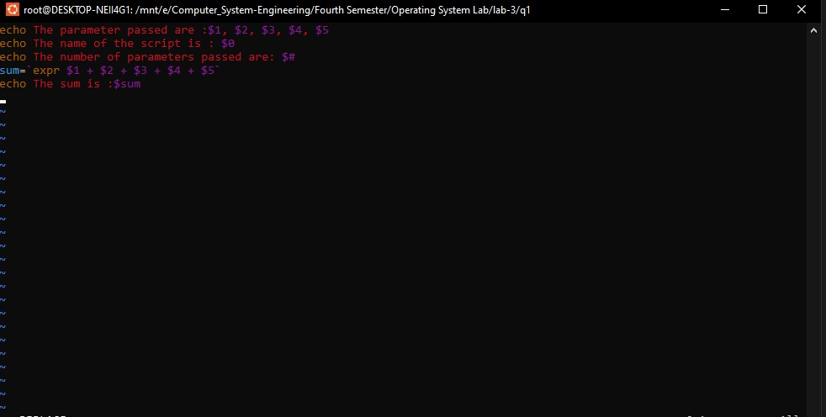

**Output:**

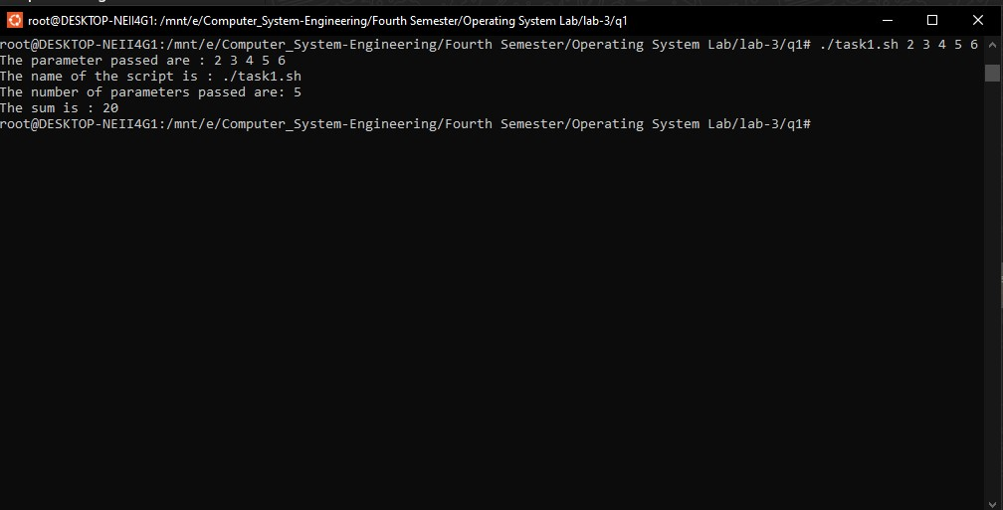

**Example 2:**

Write a script which will accept different numbers and finds their sum. The number of parameters can vary

**Code:**



**Output:**

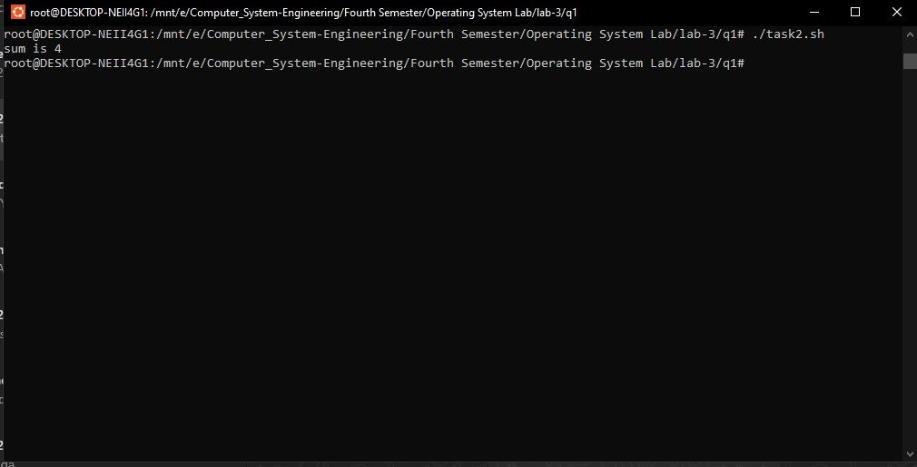

Example 3:

**Code:**

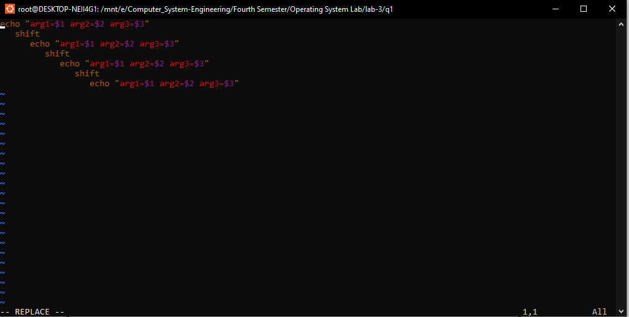

**Output:**

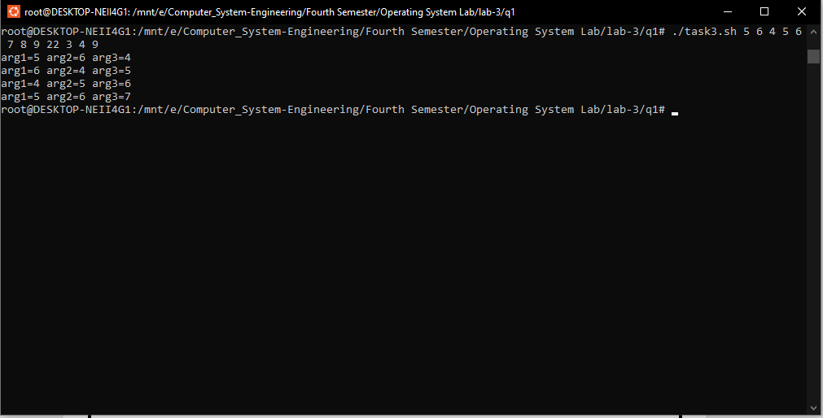

**Example 4:**

**Code:**

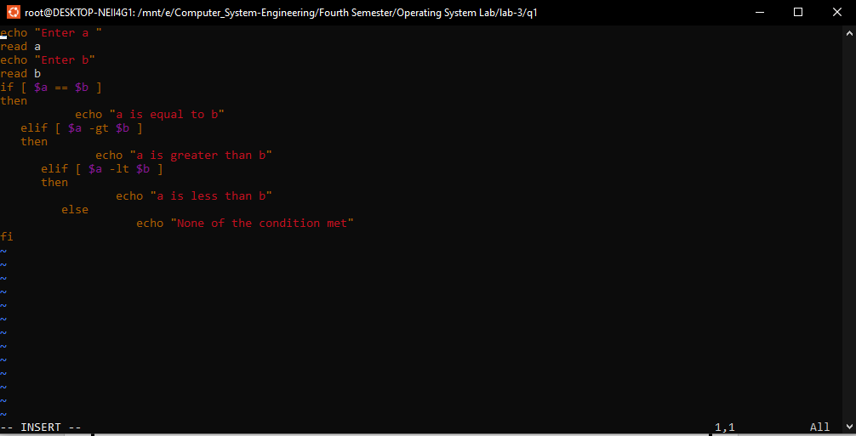

**Output:**

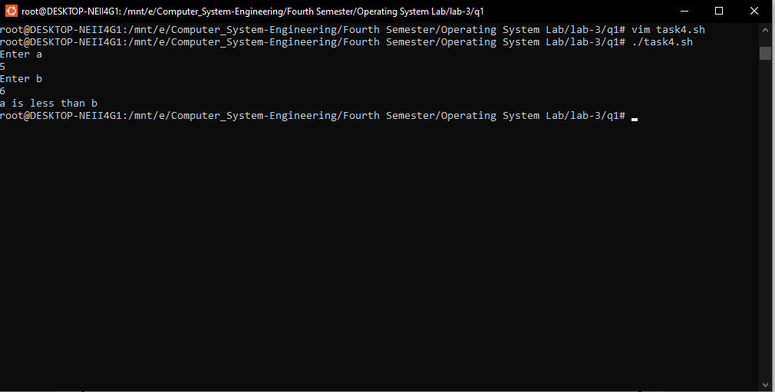

**Example 5:**

**Code:**

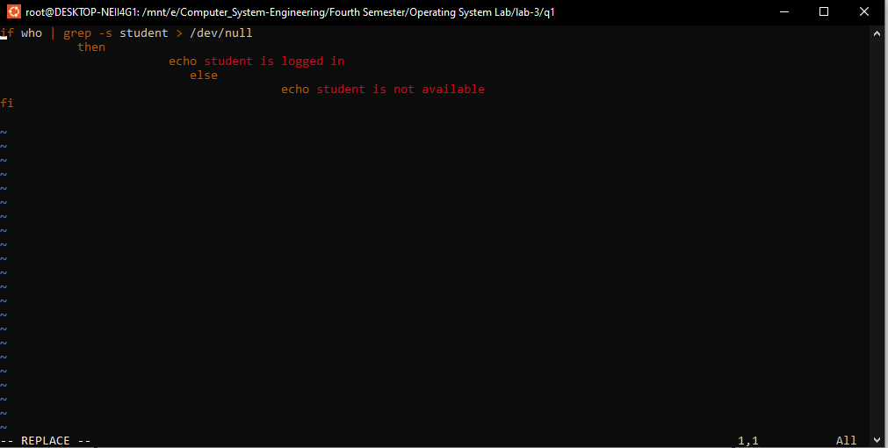

**Output:**

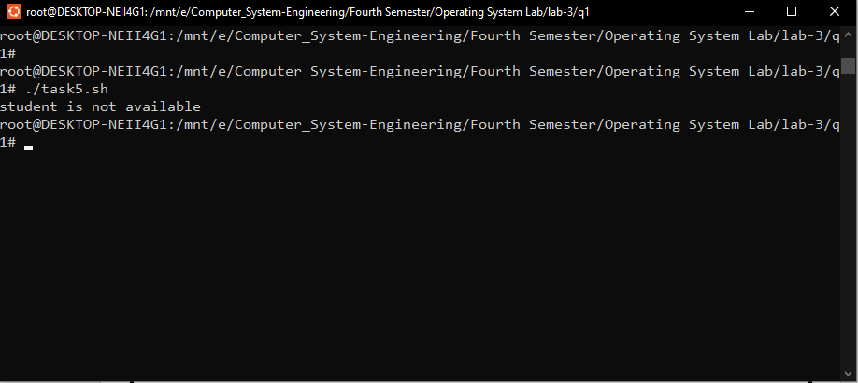

**Example 6:**

**Code:**

Display a menu of options and depending upon the user's choice,

#execute associated command

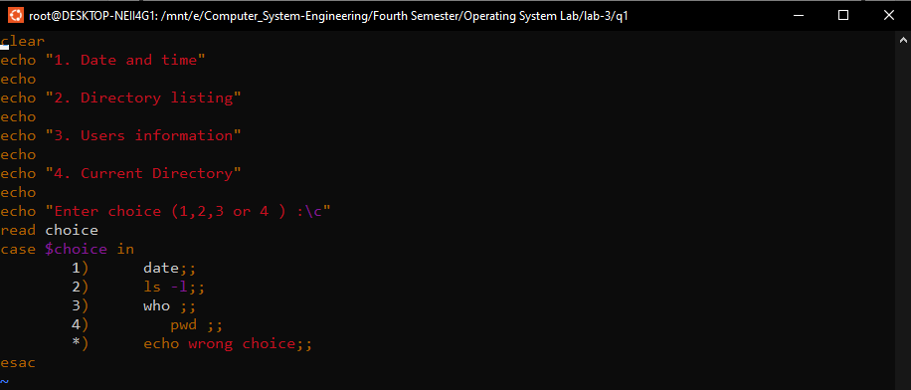

**Output:**

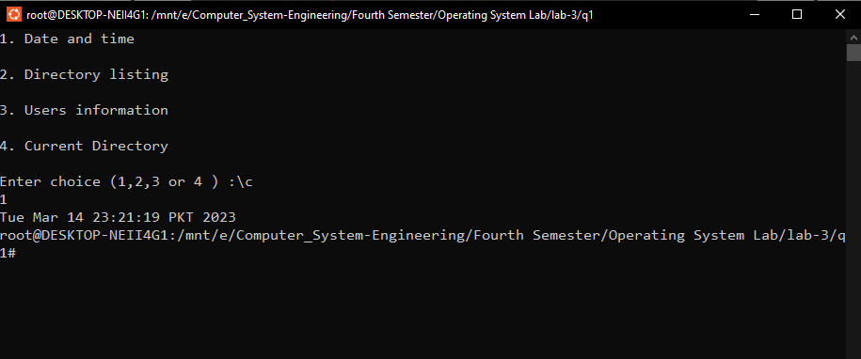

**Example 7:**

see if a number of people are logged in

**Code:**

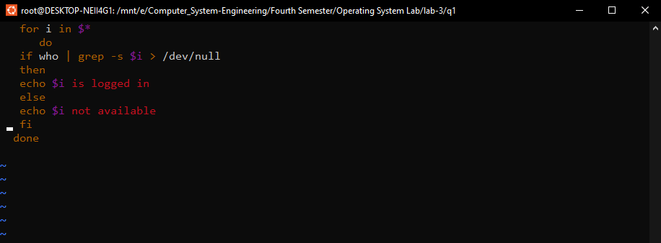

**Output:**

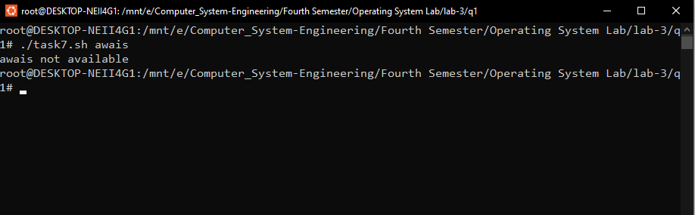

**Example 8:**

**Code:**

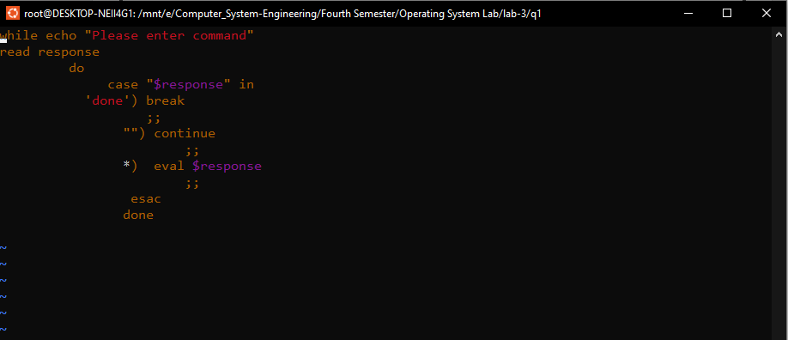

**Output:**

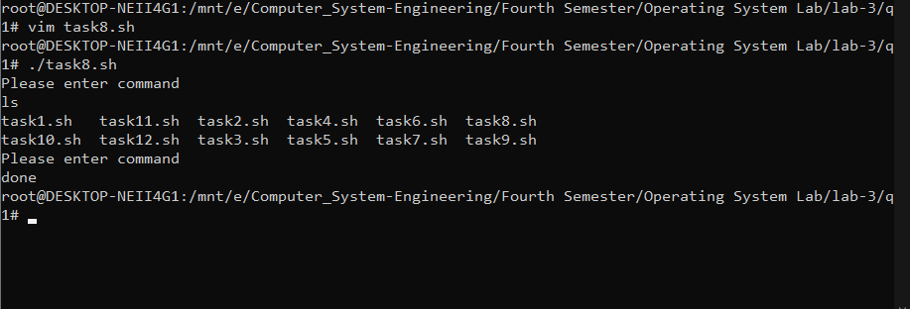

**Example 9:**

To show use of case statement.

**Code:**

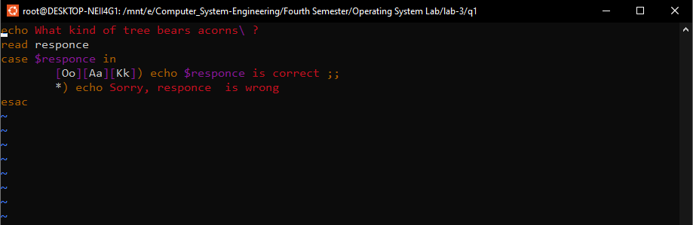

**Output:**

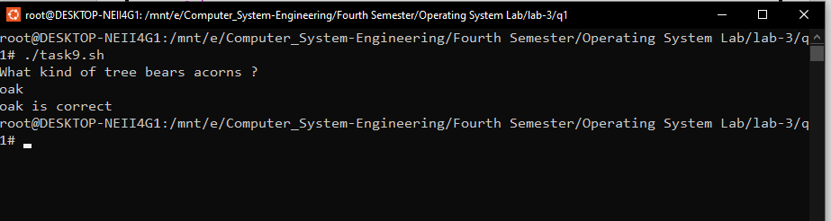

**Example 10:**

**Code:**

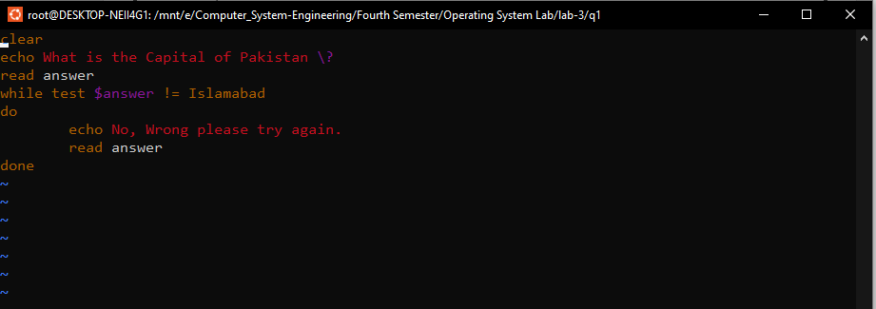

**Output:**

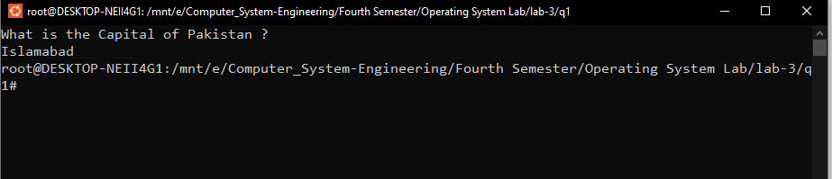

**Example 11:**

Example to show use of until statement. Accept the login name from the user

**Code:**

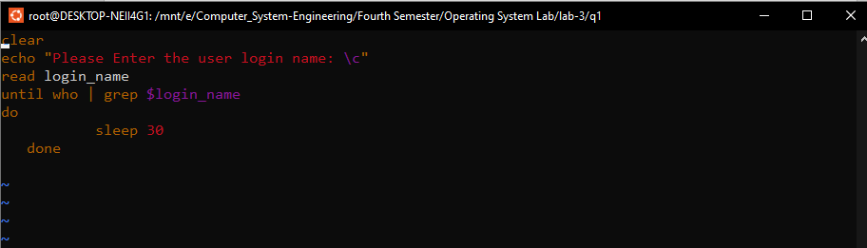

**Output:**

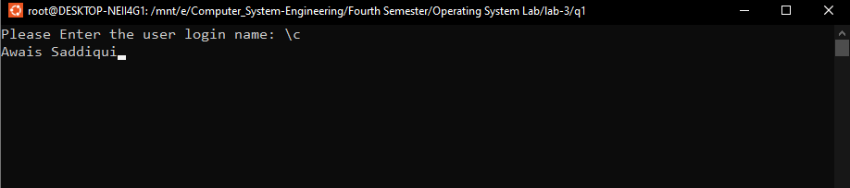

**Example 12:**

**Code:**

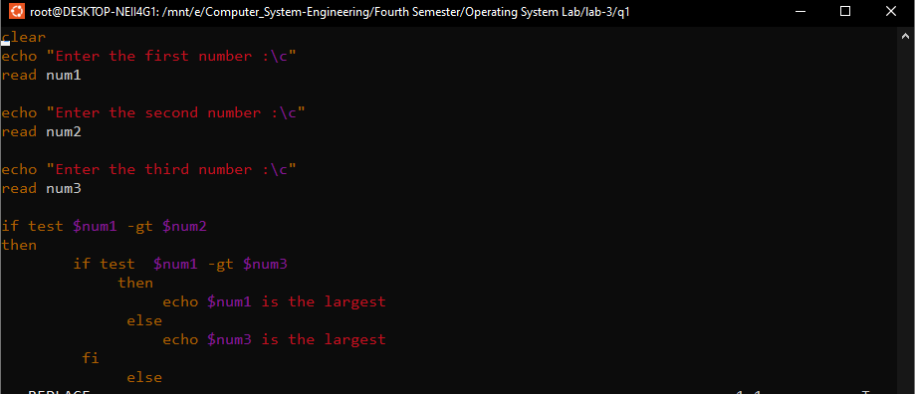

**Output:**

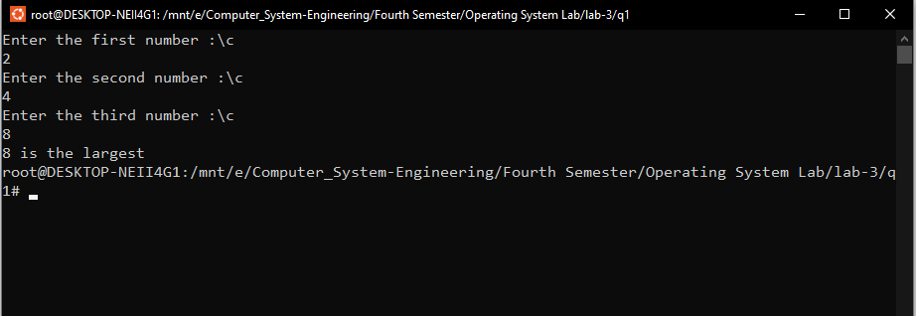

**Assignment Problems on UNIX SHELL programming**

**Q_2: .** Write a shell script that takes a keyword as a command line argument and lists the filenames containing the keyword

**Code:**

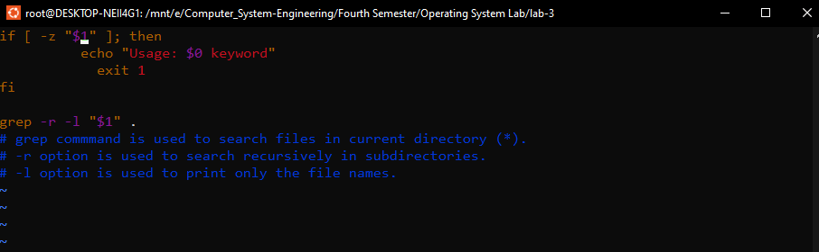

**Output:**

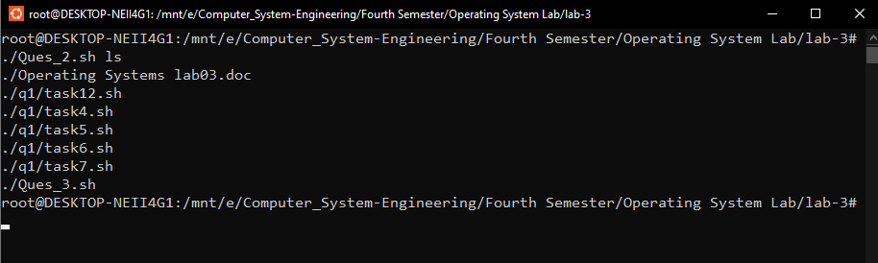

**Q_3:** Write a shell script that takes a command line argument and reports whether it is a directory, or a file or a link.

**Code:**

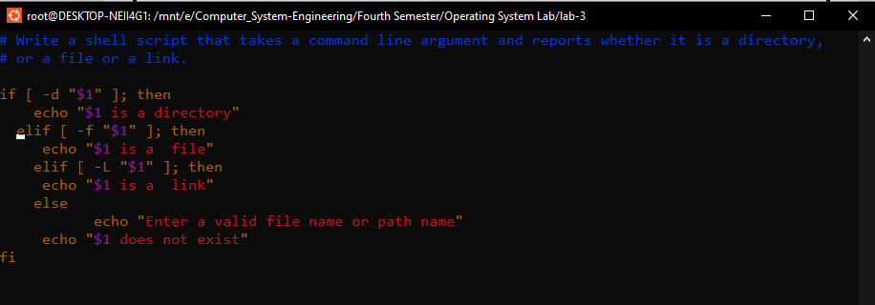

**Output:**

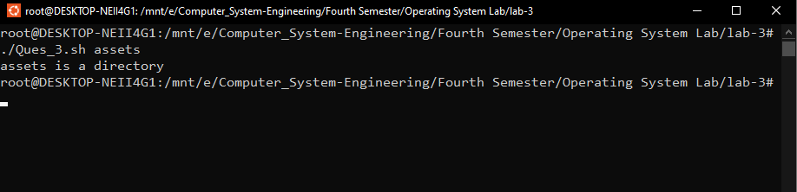

**Q_4:** Write a script to find the number of sub directories in a given directory.

**Code:**

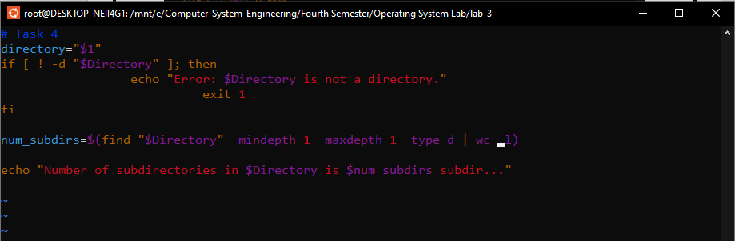

**Output:**

